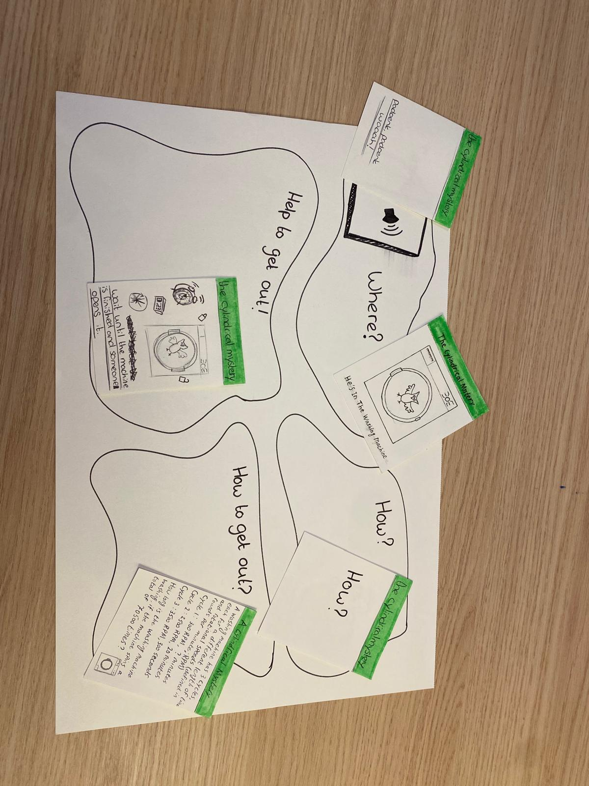

**Happy stories**

Happy stories is designed to be a child-friendly spin-off of Black stories. In black stories one player, the reader, gets a promt he should read, for example:’ A man is laying on the pavement with red smush besides him’. Then the other player has to ask yes or no questions to figure out where he is, what happened and why. However someone dies in every ‘black story’; Not proper for six year olds.

The happy stories variant, doesn't end in death, but is a fun story about Arne's favourite plushie, nr. 1. The story in the game's prototype started with a cryptic hint; badoenk, badoenk. Whaaaahh!, the goal was that Arne would ask questions until he figured out that nr.1 was in the washing machine.

After the ‘where’ he should continue with the ‘how’; How did nr.1 end up in the washing machine. The reason was, he was painting, fell into the paint, and needed to be cleaned.

Lastly Arne needed to figure out a way to help nr.1 get out and solve a calulation before he ‘won’ the game.

**Evaluation**

During the co-design session the game was not used, this is partly due to the semi-unstructured nature of the session, and partly due to the knowledge that Arne was nog great at asking questions. The principle of the game was explained to Daniël near the end of the co-design session, he confirmed the assumption that it would be near impossible to get Arne to ask questions, since he would not see the use of asking questions in this case.