# Ideation matching

**3 (1/2):**

There are two ducks in front of a duck, two ducks behind a duck and a duck in the middle. How many ducks are there?

*Answer: Three. Two ducks are in front of the last duck; the first duck has two ducks behind; one duck is between the other two.*

**3 (2/2):**

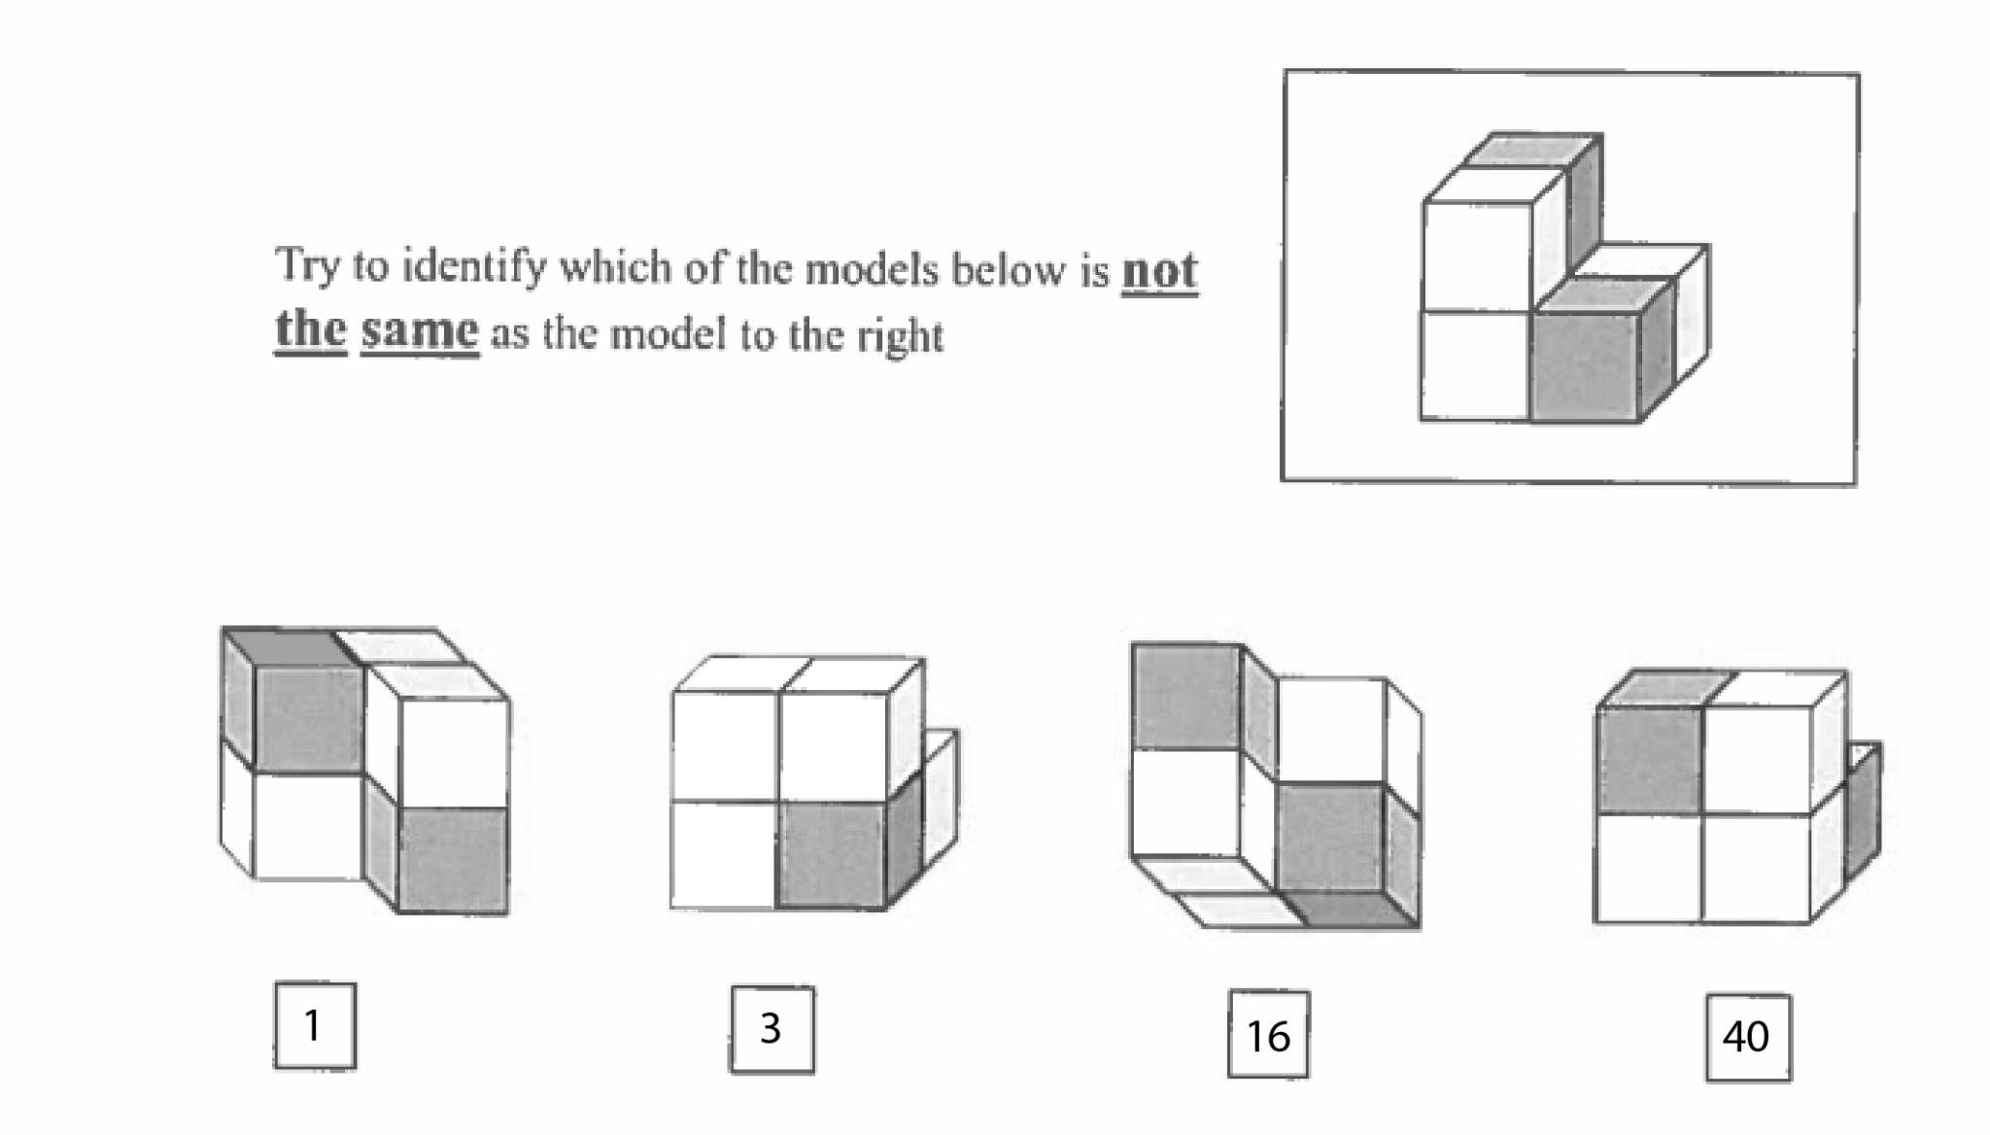

**9 (1/2):**

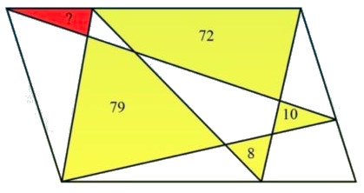

*Answer: To solve this fun maths question, you need to understand how the area of a parallelogram works. If you already know how the area of a parallelogram and the area of a triangle are related, then adding 79 and 10 and subsequently subtracting 72 and 8 to get 9 should make sense.*

**9 (2/2):**

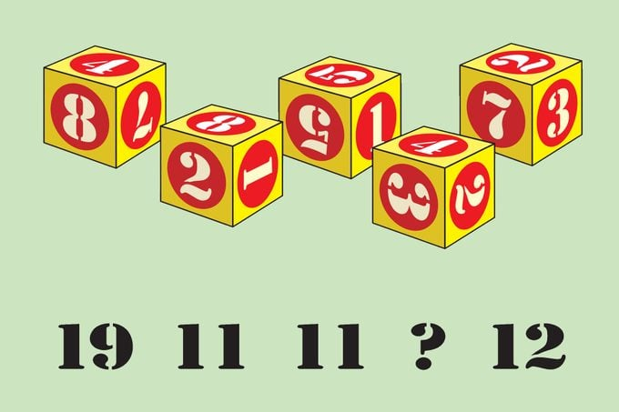

**11 (1/2):**

Susan and Lisa decided to play tennis against each other. They bet €1 on each game they played. Susan won three bets and Lisa won €5. How many games did they play?

*Answer: Eleven. Because Lisa lost three games to Susan, she lost €3 (€1 per game). So, she had to win back that €3 with three more games, then win another five games to win €5.*

**11 (2/2):**

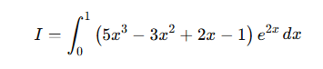

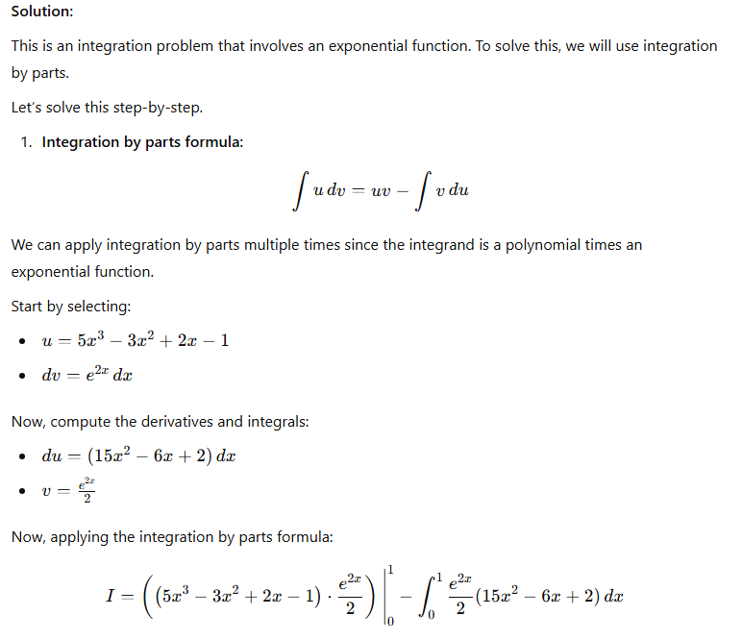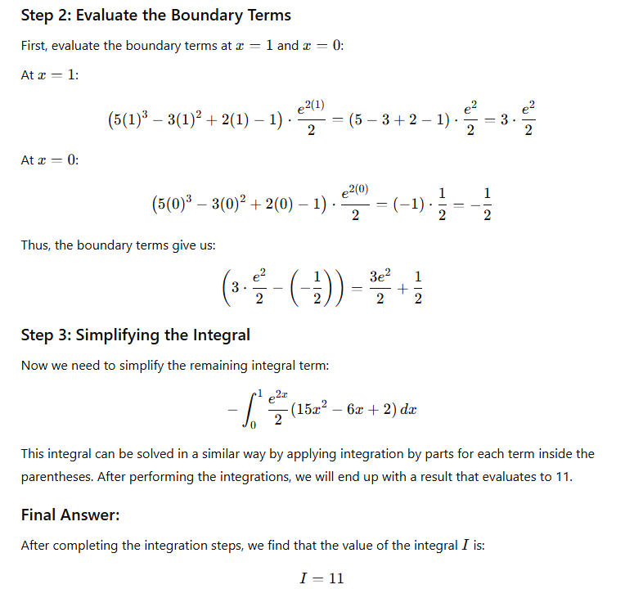

**40 (1/2):**

A man has 53 socks in his drawer: 21 identical blue, 15 identical black and 17 identical red. The lights are out, and he is completely in the dark. How many socks must he take out to make 100 percent certain he has at least one pair of black socks?

*Answer: 40 socks. If he takes out 38 socks (adding the two biggest amounts, 21 and 17), although it is very unlikely, it is possible they could all be blue and red. To make 100 percent certain that he also has a pair of black socks he must take out a further two socks.*

**40 (2/2):**

