Information about LOCO

Also known as:

or LÜK ("lernen, üben, kontrollieren) (GER)

or Tutor Systems (ENG)

BASIC INFO.

Includes:

* A workbook,
* A flat red box ("Tutor plastic tray") with small depressions and
* A number of tiles that fit into the depressions and are printed on both sides - on the front with a number, on the back with the part of a motif.

HOW TO USE:

* The objective is to solve a set of tasks from the workbook and
* insert the tiles into the tray according to the results.
* The tray is then closed, turned over and re-opened -
* Compare the pattern on the back of the tiles and the printed drawing in the workbook,
* See if all the tasks have been solved correctly

**DESIGN RELEVANCE / IDEATION / OPPORTUNITIES**

* We can create a blank version so that whatever our participant needs or wants to learn, he can practice it with a version of the Loco product ?

Information about SET:

https://www.vvsor.nl/wp-content/uploads/2018/11/STAtOR-2019-2-10-13-Gijswijt.pdf

**Print source:** [**https://stefan.endrullis.de/en/game_set.html**](https://stefan.endrullis.de/en/game_set.html)

**BASIC RULES**

A set consists of three cards satisfying all of these conditions:

* They all have the same number or have three different numbers.
* They all have the same shape or have three different shapes.
* They all have the same shading or have three different shadings.
* They all have the same color or have three different colors.

“If you can sort a group of three cards into "two of ____ and one of ____", then it is not a set”

“Given any two cards from the deck, there is ***one and only one*** other card that forms a set with them”

1. Dealer lays out 12 cards on the table
2. If someone sees a set they call out "Set!". They then take the cards in the set,
3. Dealer lays three more cards on the table.
4. There may be no set among the twelve cards; in this case, the dealer deals out three more cards to make fifteen dealt cards, or eighteen or more, as necessary
5. Finding sets continues until the deck is exhausted and there are no more sets on the table.
6. Whoever has collected the most sets wins

IMPORTANT: (To call out "set" and not pick one up quickly enough results in a penalty)

**BACKGROUND**

A complete set is 81 cards

Given any two cards, there is exactly one card that forms a set with those two cards. Therefore, the probability of producing a Set from 3 randomly drawn cards from a complete deck is 1/79.

A *cap set* is a mathematical structure describing a Set layout in which no set may be taken. The largest group of cards that can be put together without creating a set is 20, proven in 1971 (cap sets were studied before the game).[]](https://en.wikipedia.org/wiki/Set_%28card_game%29#cite_note-8)

This is called maximal cap set

(Source said: (sequence [A090245](https://oeis.org/A090245) in the [OEIS](https://en.wikipedia.org/wiki/On-Line_Encyclopedia_of_Integer_Sequences)) - not sure what this means)

There are 682344 such cap sets of size 20 for the 81-card version of Set; under affine transformations on 4-dimensional finite space, they all reduce to essentially one cap set.

(Donald Knuth, 2001)

* He is the 1974 recipient of the ACM Turing Award (computer science)
* Knuth has been called the "father of the analysis of algorithms"

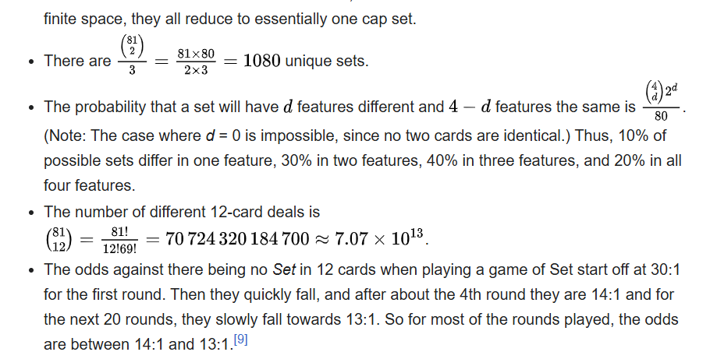

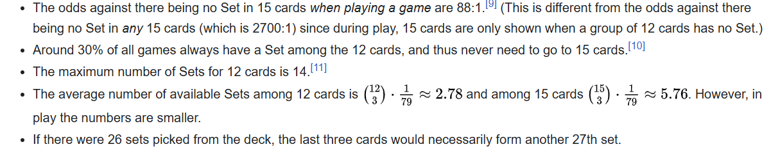

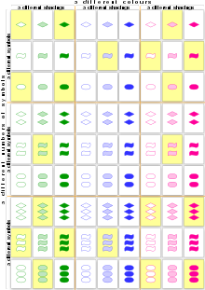

**GAME VISUAL**

**GAME VARIANTS**

<http://magliery.com/Set/SetVariants.html>

Example: Concentration Set (if original Set is not challenging enough)

* Lay out all 81 cards face down. Decide who goes first in some reasonable manner.
* Players take turns turning over three cards of their choice in hopes that they will be a Set
* If the three cards turned over are a Set, the player gets to collect and keep them, and turn over three more. Otherwise, the cards are turned back over and the player's turn ends.
* The game ends when all players agree that the remaining cards contain no Set.
* Whoever collects the most Sets wins!

Example: Complex Set

Play SET® as normal, but when you make a correct Set call, instead of removing all three cards, remove any *one* of the three cards used to make the Set. This allows you to involve cards that stay on the table in more than one Set, if you can.

This variation has a couple of advantages: The first is that any individual game lasts much longer. The second is that experienced players will leave spotted Sets on the table while searching for other Sets, giving slower players a chance to dive in. As usual, whoever collects the most Sets wins.

**DESIGN RELEVANCE / IDEATION / OPPORTUNITIES**

The math function basis of this game, with a lack of actual math or numbers involved, makes it more fun and puzzle like- repeatable game that passes the hurdle of our participant’s photo-graphic memory.

Very interesting math behind “Cap Set” - may be introducing him to concepts he has not yet learnt about.

* Promotes communication and interaction with others from our participant as its a multiplayer game, sometimes you have to explain why your Set works.

We would ideally personalise the game to suit our participants’s interests

He can input his own designs perhaps to draw his own shapes or use his own colours

IDEA = Instead of shapes, colours, involve music, language, or math symbols (perhaps it could be prime sets etc.)

Using the ‘cap set’ concept, NOT necessarily the game Set, as our guiding direction for the product.

The game Set is just a way of explaining/conceptualising the usage of ‘cap sets’ in a gamified product